Exp No : 15
SERIAL INTERRUPT USING UART (KEYBOARD INPUT) IN KEIL
AIM : To write and simulate an Embedded C program using serial interrupt in 8051 microcontroller such that while a message is continuously transmitted, any key pressed from the keyboard generates an interrupt and is displayed through UART.
SOFTWARE REQUIRED :
- PC with Windows OS
- Keil $μ$Vision IDE
- 8051 Simulator (Keil built-in)
- Serial Window (UART #1)
PROGRAM :
#include <reg51.h>
#include <stdio.h>

void serial_ISR(void) interrupt 4
{
char ch;
if (RI)
{
RI = 0; // Clear receive interrupt flag
ch = SBUF; // Read received character

printf("\n>>> INTERRUPT RECEIVED: ");
printf("%c\n", ch);
}
}

void delay(void)
{
unsigned int i;
for(i = 0; i < 50000; i++); // Delay for visibility
}

void main(void)
{
SCON = 0x50; // UART mode 1, 8-bit, REN enabled
TMOD = 0x20; // Timer1 mode 2 (auto-reload)
TH1 = 0xFD; // Baud rate 9600
TR1 = 1; // Start Timer1

IE = 0x90; // EA = 1, ES = 1 (enable serial interrupt)

TI = 1; // Enable printf

while(1)
{
printf("Hello World\n");
delay();
}
}

Circuit Diagram:
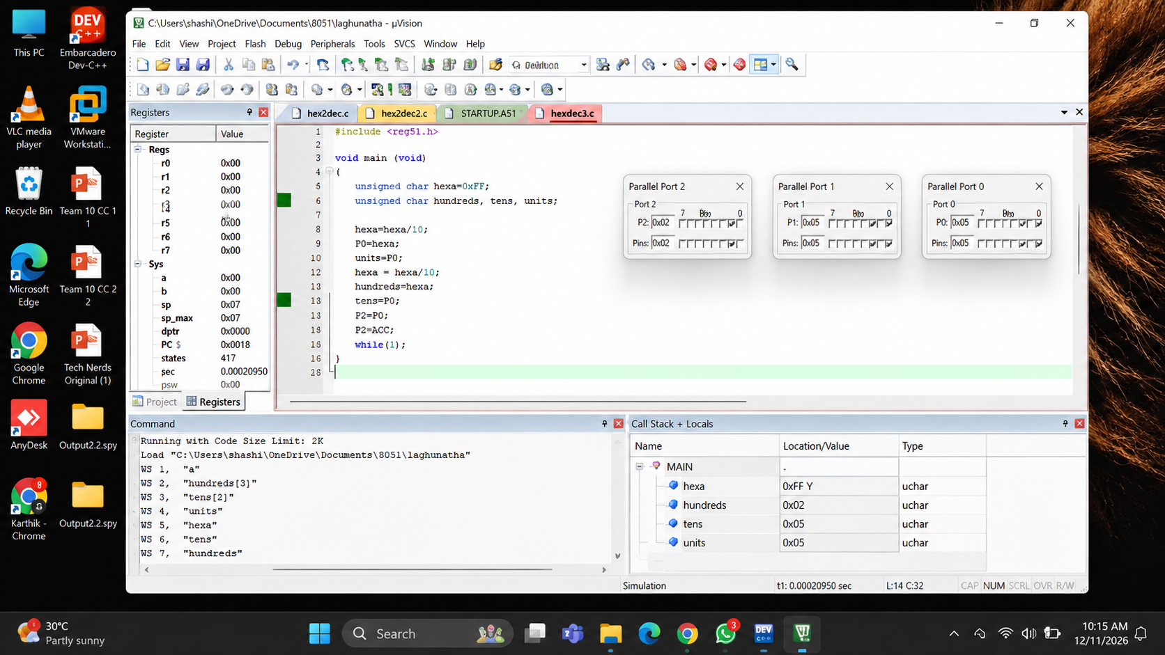

RESULT :
Thus, the serial interrupt using UART was successfully implemented and verified in Keil simulator. The interrupt was triggered upon keyboard input and serviced correctly using an Interrupt Service Routine.

